Car-Dun-Al O.D.T.C.
Gail McEvilly
535 Eagle Ridge Ln
Algonquin, IL 60102

CarDunAl Dog Training Club
Temperament Test Premium List
(Open to all breeds)

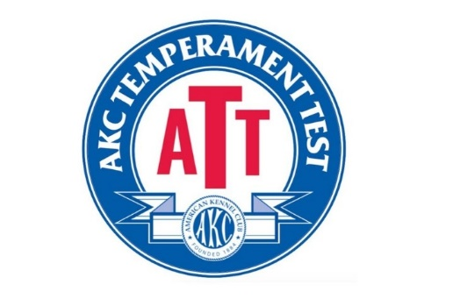
Sunday June 28, 2026

Test Event #’s 2026055038
Test Event #’s 2026055039
Unbenched - Indoors
(Licensed by the American Kennel Club)

Closing 6/10/26 at 6:00 p.m.
At the home of the secretary
Gail McEvilly
535 Eagle Ridge Ln
Algonquin, IL 60102

Car-Dun-Al ODTC Building
10783 Wolf Drive
Huntley, Illinois 60142
DO NOT mail entries to this address
Trial Hours: 8:00 to 6:00 P.M. CST.
ENTRY METHOD: FIRST RECIEVED
Limit for each test is 50 dogs

President Jerry McEvilly
Car-Dun-Al Obedience Dog Training Club Officers

1st. Vice President Denise Farley
2nd. Vice President Bonnie Morrow
Corresponding Secretary Martha LaLoggia
9265 S Union Rd, Huntley, IL. 60142
Recording Secretary Heidi Nelson
Treasurer Patti Burgess
Director of Training Carol Preble
Director of Agility Shauna Lindelof
Board of Directors:
Jean Munger, Gail McEvilly, Debbie Grex

Trial Secretary -
Gail McEvilly
535 Eagle Ridge Ln, Algonquin, IL 60102
224-392-1791 gailmcevilly@gmail.com

Trial Chairman -
Ed Ronan
88 Summit Drive, Gilberts, IL 60136
847-471-5739– ejronan42@gmail.com

Judges: Trial #1 – Sheryl Phelps, Berwyn, IL Alt: Marian Walters
Trial #2 – Carol Preble, Marengo, IL Alt: Marian Walters

Committee – Debbie Orman, Jerry McEvilly, Ed Ronan, Gail McEvilly & Martha LaLoggia
​

ENTRY FEES PER TEST
Entry Fees for each test: $25.00
Mail entry forms and fees to:
Gail McEvilly
535 Eagle Ridge Ln, Algonquin, IL 60102

ENTRY LIMITS/WAITING LIST/MULTIPLE DOGS
There will be an entry limit of 50 dogs per test.
Once entry limits have been met an unlimited wait list will be maintained.
Handlers are eligible to test multiple dogs in a test.
Entries will be accepted on a first come basis and will not be accepted on the day of the tests if entry limits have not been met.
Please make checks payable to CarDunAl ODTC
No entries will be accepted by phone, email or fax. Express mail entries must include the signature waiver allowing them to be left at the secretary’s address. Inquiries may be directed to Carol Preble at lodgepole@foxvalley.net. No entry shall be made, and no entry shall be accepted which specifies any conditions as to its acceptance. Returned checks do not constitute a valid entry. Illegible entries will not be processed and will be returned to the exhibitor. The trial secretary will add a $35.00 collection fee to the amount of each returned check.
DOG ELIGIBILITY
Dogs who are at least 1 year of age are eligible to take the ATT and must either be AKC or FSS registered or listed with Canine partners or have a Purebred Alternative Listing number. Dogs that are spayed or neutered may participate. Dogs must be able to perform whole categories of the test (such as hearing auditory stimuli and seeing visual stimuli), in order to be eligible to earn an ATT title. Dogs with disabilities such as those that are blind, deaf, or have three legs are eligible to enter provided in the opinion of the evaluator they display no signs of physical discomfort and can safely complete the test. However, if a dog has multiple disabilities such that it is unable to complete whole categories of the test (i.e. – hearing auditory stimuli and seeing visual stimuli), the dog would not earn the ATT title.

Bitches in season ARE allowed to enter.
Safety, Behavior and Liability
The safety of the dog is our primary concern. By entering this trial, exhibitors acknowledge that they are familiar with the rules and regulations of this sport, and that their dogs are familiar with and able to perform all exercises safely. It is expressly understood that exhibitors alone are responsible for the behavior of their dogs and/or children. Any exhibitor whose dogs and/or children create an unnecessary disturbance or repeatedly engage in unsafe or disruptive behavior may, at the discretion of the trial committee, be asked to leave the show site. In such case, no refund of any fees paid will be made. CarDunAl ODTC and its agents, employees, etc. will assume no responsibilities for any loss, damage, or injury sustained by exhibitors or handlers, or to any of their dogs or property and further assumes no responsibility for injury to children. CarDunAl ODTC reserves the right to decline entries for cause and may remove any dog on account of aggression. No one shall have any recourse or claim against CarDunAl ODTC or any official thereof.

Collars, Leashes and Harnesses
Dogs may wear slip collars that are on a dead ring, buckle collars, martingales and body harnesses in the ATT. They may not wear prong collars, head collars, e-collars, or harnesses that restrict the movement of the dog. Leashes should be 4 ft. or 6 ft. long and should be made of fabric or leather.

All dogs must be on leash at all times, and retractable leashes may not be used when on trial grounds (except during judged exercises). Dogs must enter and exit the trial area with the leash attached to the collar or harness, including when waiting in the trial area and after the event. An off-leash option may be offered at the discretion of the judge, only if the area is completely enclosed.

Refunds
No entry fee will be refunded if the trial cannot open or be completed by reason of riots, civil disturbances, fire, an act of God, public emergency, act of a public enemy, or any other cause beyond the control of the organizing committee. No entry fee will be refunded in the event a dog is absent, disqualified, excused, or barred from competition by the action of the Trial Committee. Dogs pulled after closing because of injury or other medical condition are not eligible for a refund.

AKC Rules, Regulations, Policies and Guidelines are available on the American Kennel Club website: www.akc.org
AGREEMENT
I certify that I am the actual owner of the dog, or that I am the duly authorized agent of the actual owner whose name I have entered above. In consideration of the
acceptance of this entry, I (we) agree to abide by the rules and regulations of The American Kennel Club in effect at the time of this event, and any additional rules and regulations appearing in the premium list of this event and entry form and any decision made in accord with them. I (we) agree that the club holding this event has the right to refuse this entry for cause which the club shall deem sufficient I (we) certify and represent that the dog entered is not a hazard to persons or other dogs. In consideration of the acceptance of this entry and of the holding of this event and of the opportunity to have the dog judged and to win prizes, ribbons, or trophies, I (we) agree to hold the AKC, the event-giving club, their members, directors, governors, official agents, superintendents or event secretary and the owner and/or lessor of the premises and any provider of services that are necessary to hold this event and any employees or volunteers of the aforementioned parties, and any AKC approved judge, judging at this event, harmless from any claim for loss or injury which may be alleged to have been caused directly or indirectly to any person or thing by the act of this dog while in or about the event premises or grounds or near any entrance thereto, and I (we) personally assume all responsibility and liability for any such claim; and I (we) further agree to hold the aforementioned parties harmless from any claim for loss, injury or damage to this dog. .Additionally, I (we) hereby assume the sole responsibility for and agree to indemnify, defend and save the aforementioned parties harmless from any and all loss and expense (including legal fees) by reason of the liability imposed by law upon any of the aforementioned parties for damage because of bodily injuries, including death at any time resulting therefrom, sustained by any person or persons, including myself (ourselves), or on account of damage to property, arising out of or in consequence of my (our) participation in this event, however such, injuries, death or property damage may be caused, and whether or not the same may have been caused or may be alleged to have been caused by the negligence of the aforementioned parties or any of their employees, agents, or any other person. I (we) agree that the determination of whether the injury is serious shall be made by the event veterinarian and is binding on me (us). I (WE) AGREE THAT ANY CAUSE OF ACTION, CONTROVERSY OR CLAIM ARISING OUT OF OR RELATED TO THE ENTRY, EXHIBITION OR ATTENDANCE AT THE EVENT BETWEEN THE AKC AND THE EVENT-GIVING CLUB (UNLESS OTHERWISE STATED IN THIS PREMIUM LIST) AND MYSELF (OURSELVES) OR AS TO THE CONSTRUCTION, INTERPRETATION AND EFFECT OF THIS AGREEMENT SHALL BE SETTLED BY ARBITRATION PURSU- ANT TO THE APPLICABLE RULES OF THE AMERICAN ARBITRATION ASSOCIATION. HOWEVER, PRIOR TO ARBITRATION ALL APPLICABLE AKC BYLAWS, RULES, REGULATIONS AND PROCEDURES MUST FIRST BE FOLLOWED AS SET FORTH IN THE AKC
CHARTER AND BYLAWS, RULES, REGULATIONS, PUBLISHED POLICIES AND GUIDELINES.
Judges are not required to wait for dogs. The Owner of each dog is solely responsible for having it ready at the event area when it is to be judged. The Club has no responsibility to provide service through a public address system or stewards or runners for the purpose of calling or locating dogs that are not brought into the ring when required.

Exhibitor Check-in: At check-in, you will receive your armband number. Once the time and location for check-in is determined all exhibitors will be notified by email.

Exhibitors MUST check-in EACH event they are entered.

Ribbons
Each dog who successfully passes the test will receive a qualifying ribbon.

PLEASE Pick Up after your dog.
Anyone caught not picking up will be asked
to leave without refund of entries.

Directions to Show site:

From the east or west on I-90: Exit Route 47 (electronic I-PASS only) Go north on Route 47 approximately 3.7 miles to Oakcrest Drive and turn left (known as Algonquin Road to the right). Go less than .1 miles on Oakcrest to Wolf Drive and turn left into industrial complex. Take 1st right, drive to back, then turn left. The trial is at the far end of building.
GPS coordinates N 42.10.454 W 088.26.040.

IMPORTANT: TO ALL EXHIBITORS
– Please read carefully--

In order for us to be able to keep renting this facility please adhere to these rules.
- Please note that the building will NOT OPEN UNTIL 7:00 AM.

DO NOT COME ANY EARIER THAN 7:00 AM

- We know that some of your dogs are very exuberant and can’t help but bark. For those that are not able to prevent your dogs from barking, please park in between the buildings so our neighbors in homes to the west aren't disturbed.
- Please don't walk your dogs along the fence on the west side of the drainage area. There is a lot of area to walk on the east side of the drainage area and along the south side of the buildings.
- Please do not park in parking spots right in front of the gymnastic club or ANY of the businesses in the complex.

• If we find anyone NOT following these rules, they will be asked to leave without refund of entry fees.

Please be sure to Print Clearly on your entry form. Include the following:
- Signed entry form
- E-mail and phone on entry. E-mail confirmations will be sent to all with e-mail addresses.
- Appropriate fees
Thanks….

VETERINARIAN ON CALL

Companion Animal Specialty & Emergency Hospital
1095 Pingree Road-Suite-120
Crystal Lake, IL 60014
815-479-9119
Directions from show site: Turn right on Oakcrest Dr./Algonquin Road for 4.7 miles, then turn left on Randall Road for 4.4 miles (road name changes to James Rakow Road). Turn right on Pingree Road. Vet is in strip mall on left at corner of Rakow and Pingree.

MOTEL ACCOMMODATIONS

The following establishments have graciously agreed to accept guests with canine companions. However, we must rely on your assistance in keeping this privilege available. -- Please call to verify that pet policy has not changed.

Hampton Inn - 13000 W Illinois Dr, Huntley, IL · (847) 669-9737
2.6 miles from show site Get 12% off the list price by using the CDA Client ID 0003375101

Additional Notice to Exhibitors

PLEASE NO UNENTERED DOGS
RETURNED CHECKS does not constitute a valid entry fee.
ENTRY FEE shall not be refunded in the event that a dog is absent, disqualified, excused by the veterinarian or judge or barred from competition by action of the Trial Committee.
NO ENTRY FEES will be returned if show cannot open or be completed by reasons of riots, civil disturbances, fire, act of god, public emergencies, act of public enemy, strikes, or any other causes beyond the control of Car-Dun-Al Obedience Dog Training Club, Inc.
ERRORS ON ENTRY BLANKS Owners are responsible for errors in making out entry forms, whoever may make such errors, and no entry fee will be refunded in event of such errors or cancellation of entries after the published closing date. There will be no refund for duplicated entries. We will make every effort to find all duplicate entries but if the entry has been processed, no refund will be made.
DOGS MAY ARRIVE any time prior to their scheduled time of judging, dogs not required for further judging will be excused.
ENTRIES Must Be Made on Official AMERICAN KENNEL CLUB ENTRY FORMS. With the agreement printed on the reverse side, signed at the bottom by the owner or the owners duly authorized agent, otherwise entry cannot be accepted.

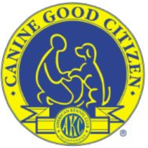

CDA is offering a CGC and CGCA test at the same time as the ATT test. Cost will be $25 per entry. Preregistration is preferred but not required. We will also offer a CGCU on Saturday, June 27, 2026. If interested contact Carol Preble at lodgepole@foxvalley.net for details.

The AKC is committed to creating a safe and respectful sport environment for all. If you need to talk to someone, or need help, please call 800. 656.HOPE (National Sexual Assault Hotline) or text HOME to 741-741 for free, 24/7, confidential services from trained crisis counselor
OFFICIAL AMERICAN KENNEL CLUB ENTRY FORM
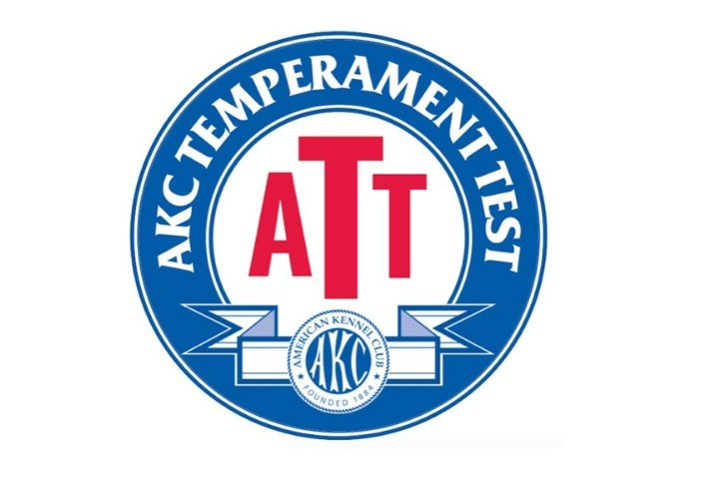
CarDunAl Obedience Dog Training Club, Inc.
10783 Wolf Drive, Huntley, Illinois 60142

Entry Fees - $25.00 per event

Test #1 – 2026055038 Judge Sheryl Phelps – Alt: Marian Walters

Test #2 – 2026055039 Judge Carol Preble – Alt: Marian Walters

ENTRIES CLOSE: 6:00 p.m. Thursday, June 24

, 2026 after which time entries cannot be accepted, canceled or substituted, or when limits are reached
MAIL ENTRIES with Fees Payable to Car-Dun-AL O.D.T.C. to Trial Secretary: Gail McEvilly
535 Eagle Ridge Ln, Algonquin, IL 60102
PLEASE PRINT.
Breed |  | Variety (1) |  |  |  |  | Sex
Call Name
AKC Registered Name
Of Dog
AKC Reg. No.  AKC Litter No.  - ILP/PAL /CAR No.  Foreign Reg. No. & Country |  |  |  |  | Date of Birth
Breeder |  |  |  | Place of Birth
Sire
Dam
Actual Owner(s) Please Print

Owners Address

City, State, & Zip Code + 4

NAME OF OWNER’S AGENT
(IF ANY) AT THE SHOW

NAME OF JUIOR HNDLER (if any) Jr.Handler #

____________________________________________________________________________
Signature of owner or agent duly authorized to make this entry:

E-MAIL ADDRESS |  |  |  | AREA CODE & PHONE NO.

