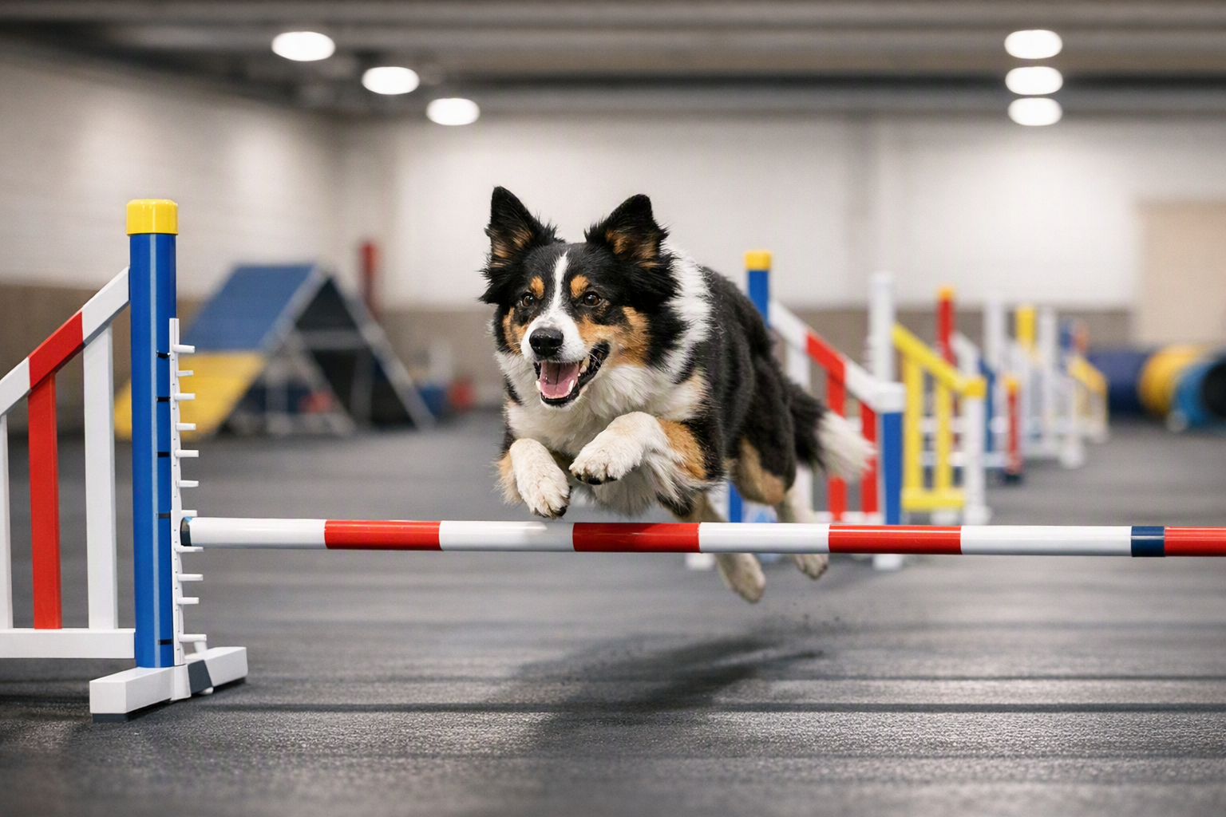
Mark your calendars! Sept 26th

AKC Agility Course Tests – Level 1 & Level 2
Who is eligible? Dogs that are currently taking lessons at CarDunAl, are at least 15 months old, and have not earned an AKC Novice or higher agility title.
Participants may choose any jump height that is comfortable for their dog.
Title Requirements:
Two qualifying runs are required to earn a title.
Event Schedule:
- Briefing: 8:30 a.m.
- First dog on the line: Following the briefing and walk thru approx. 8:45 a.m..
Cost is $20.00 per run. Registration and fees (payable to CarDunAl Dog Training) should be mailed to: Marian Walters ACT Chair
105 Fir Street
Lake in the Hills, IL 60156

